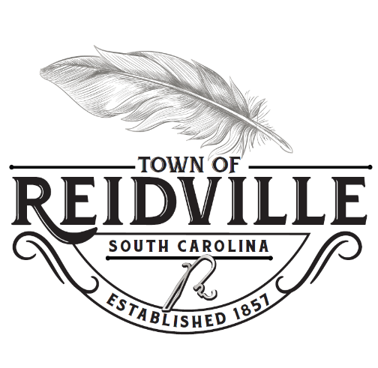
Agenda, Joint Workshop Planning & ARB
Monday May 15, 2023 6:30pm

Call to Order/Roll Call

Public Forum
(Public Comments will be limited to five (5) minutes) (Citizens who wish to have a
topic for discussion placed on the agenda, must request to do so through the Town Administrator by noon on the Wednesday prior to any council meeting)

Old Business

Reidville Main Street Monument Submission

New Business

Reidville Subdivision Sign Submission

Adjournment

